Management Summary

# What is the correlation (R2 value) between sales and income?

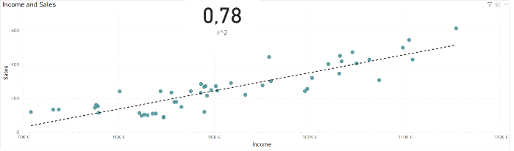Sales and income are positively correlated with a correlation factor of 0.78.

# What is the correlation (R2 value) between customer ratings and product return rate?

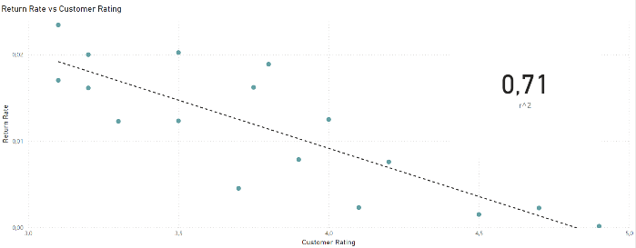Return rate and customer rating are negatively correlated with a correlation factor of 0.71.

# What are the linear regression formulas to predict customer income from customer sales?

Customer income can be predicted by sales by this formula:



# Which customer do you predict has the highest income?

The customer with the highest income is Mr John Little.

# Which product will be advertised the most?

Stock levels of Bags are on a high level. The segment of high-income customers is built of a low number of customers. These customers can be targeted very effectively. In contrast the segment of low-income customers would require high advertisement costs.

I would recommend to advertise bags to the 35 customers in the high-income segment in the first step.

Then, customers get products recommended that fit their class of income level. High earners get the bag, medium earners the sweater and low earners the T-shirt.